**AWS Task-3**

**Task Description:**

1. Create a S3 bucket, with no public access and upload files to the bucket & view the logs using cloudwatch for the uploaded files.
2. Launch two ec2-instances and connect it to a application load balancer, where the output traffic from the server must be an load balancer IP address

**Techstacks needs to be used :**

* AWS S3
* AWS EC2
* AWS Load Balancer

**1🡺 S3 Bucket Creation: -**

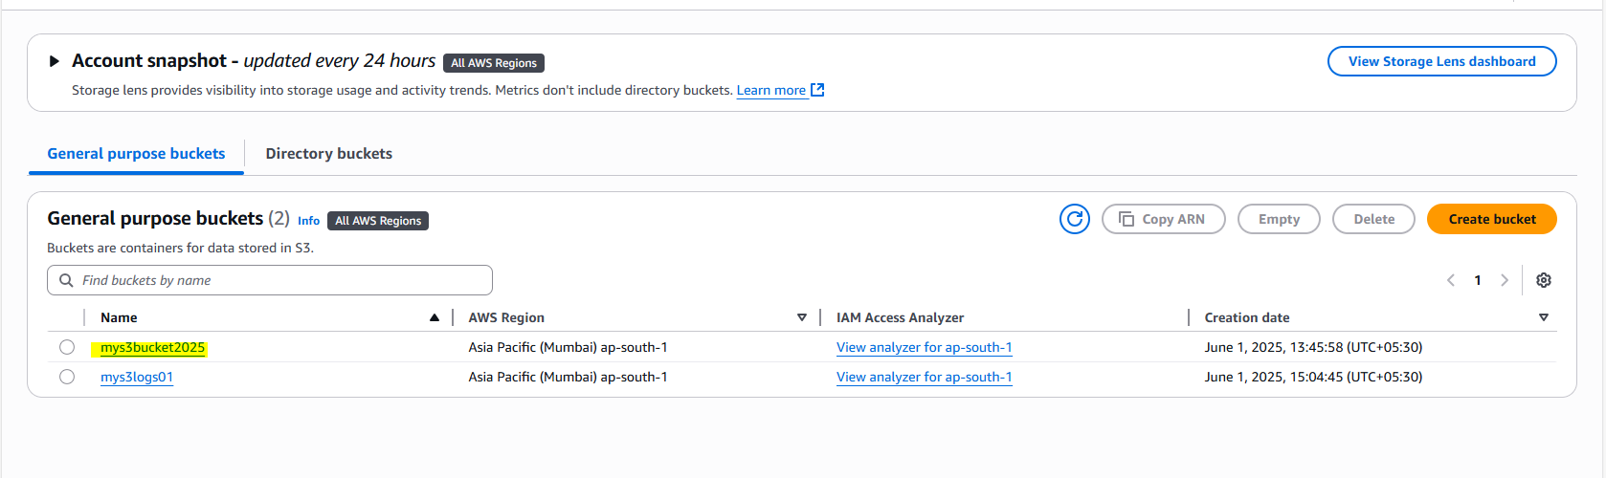

**Public Access is blocked: -**

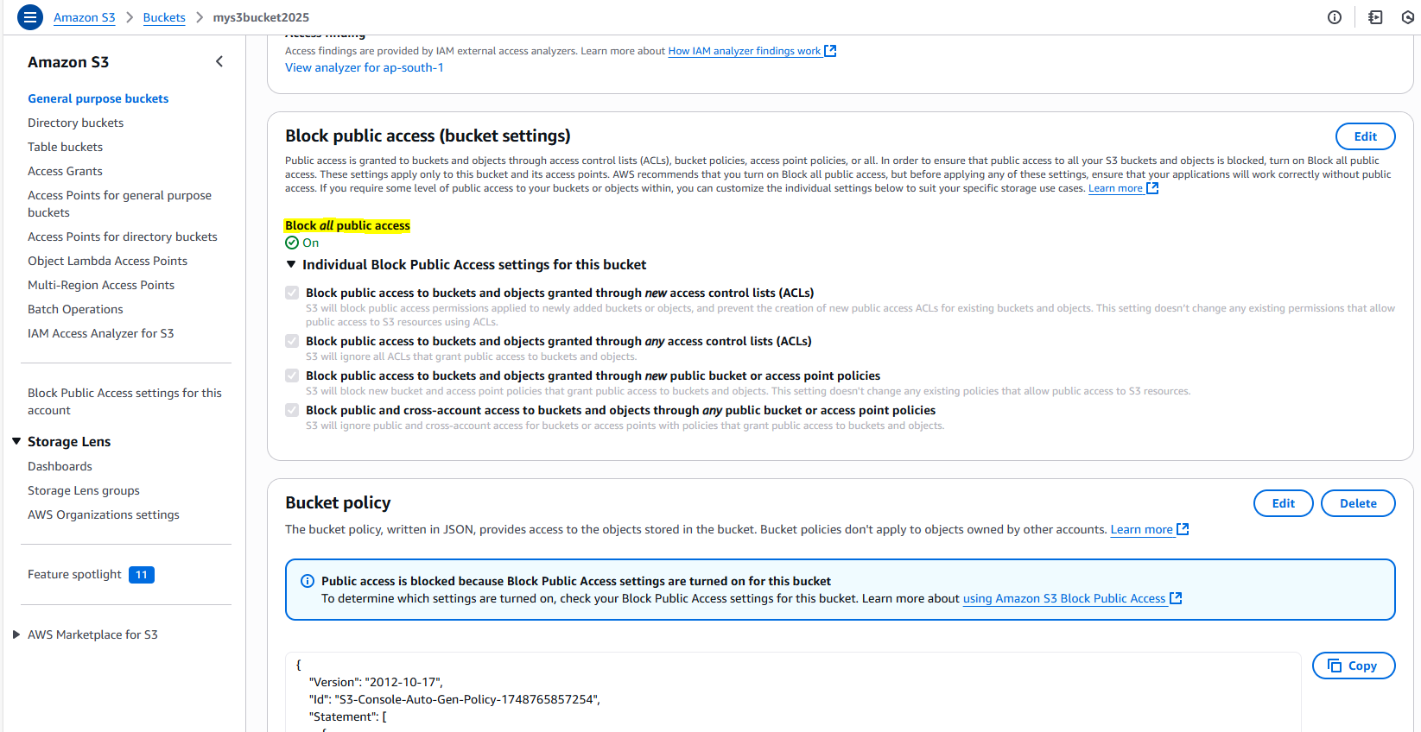

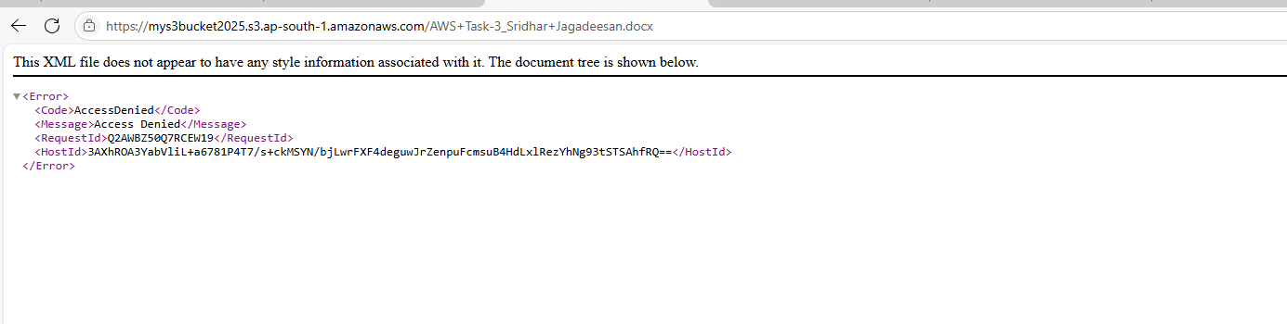

**uploading files to the bucket: -**

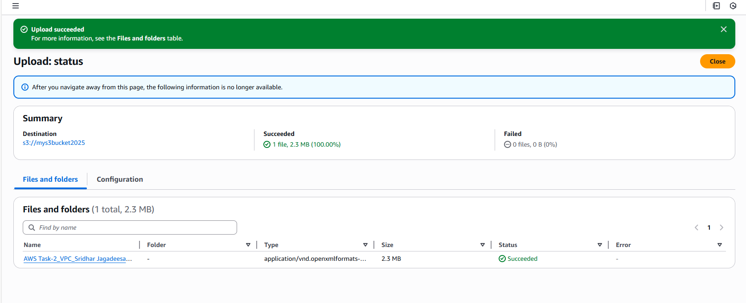

**Viewing the logs using CloudWatch for the uploaded files: -**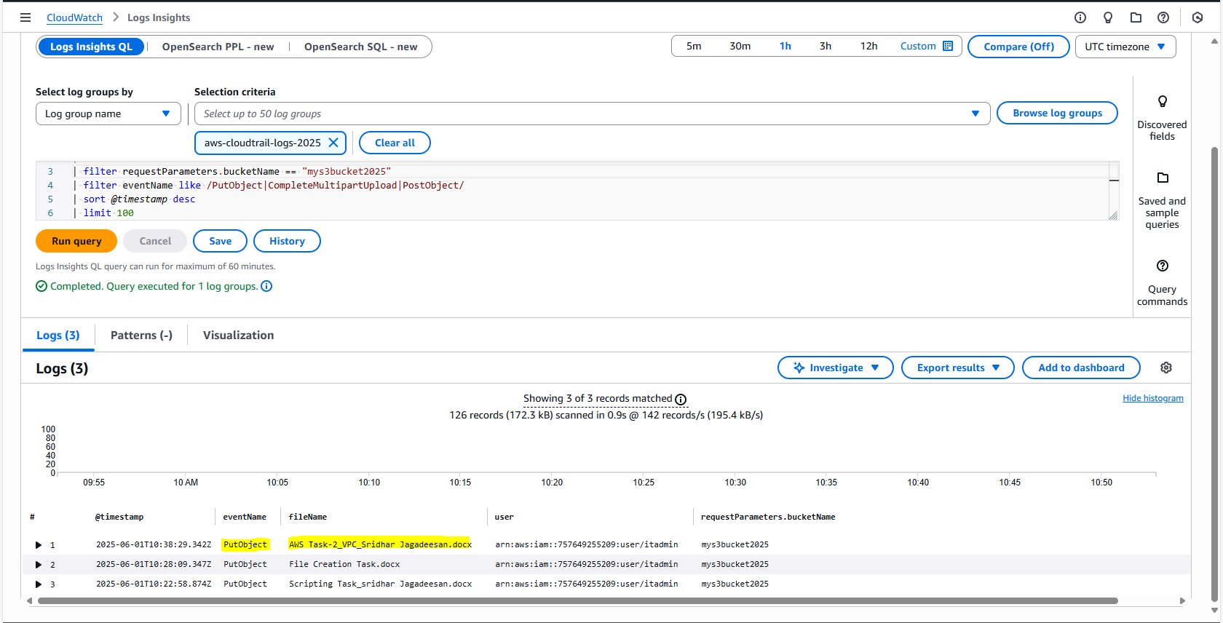

**======🡺 ======🡺 ======🡺 ======🡺**

**2🡺 Launch two ec2-instances and connect it to a application load balancer:-**

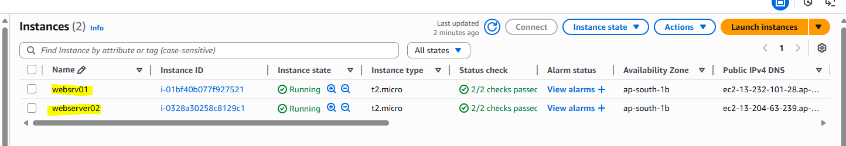

**Created Load balancer with target group: -**

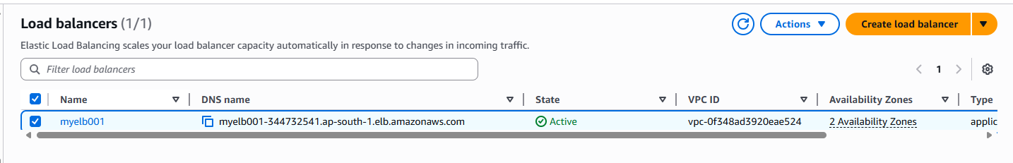

**Hitting 1’st Web server 🡺**

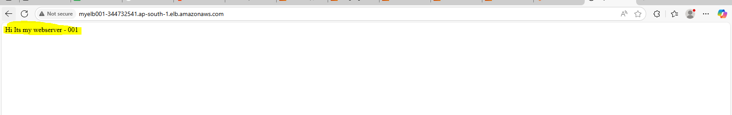

**Hitting 2’nd Web server 🡺**

